Controller as view model is a new syntax can be used on html

Controller will be exposed as constructor functtion.

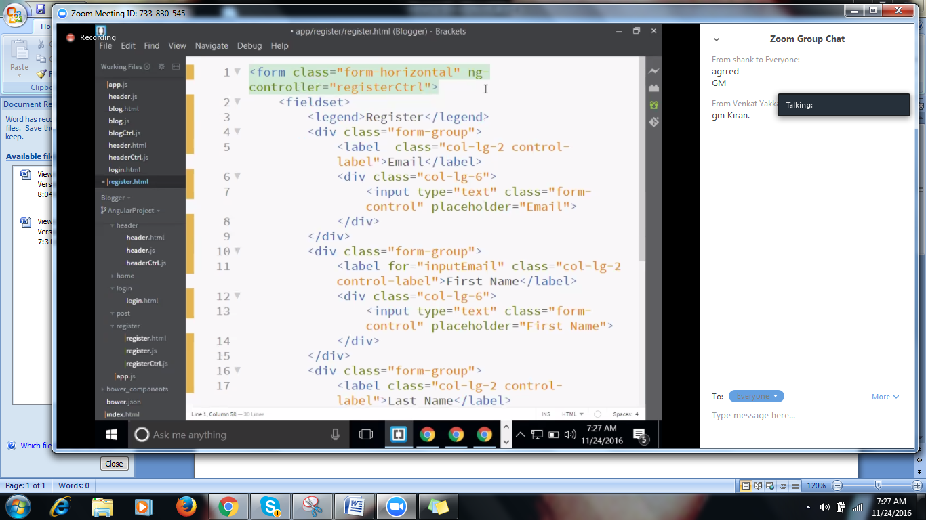

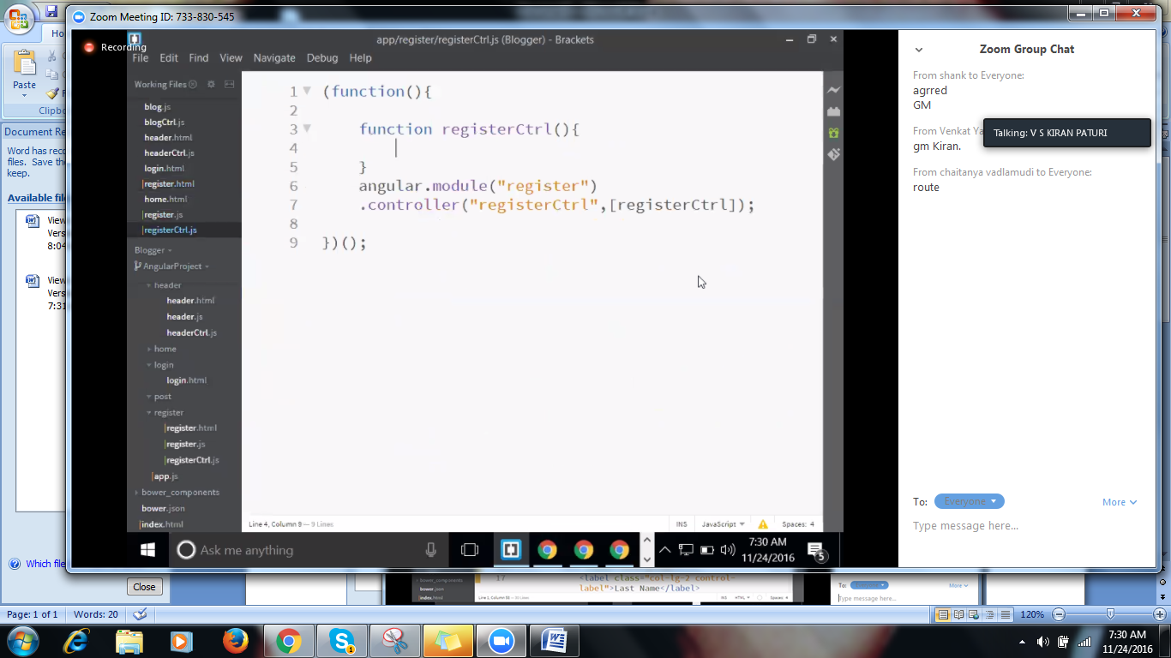

Injecting

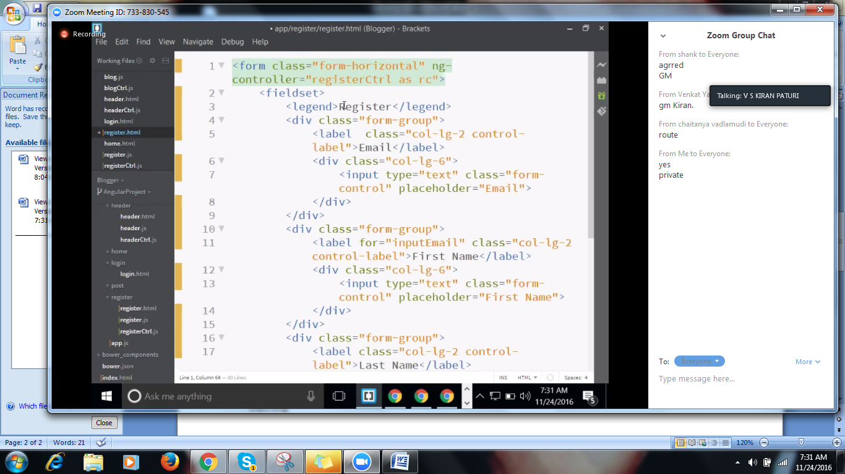

Rc is instance of register controller

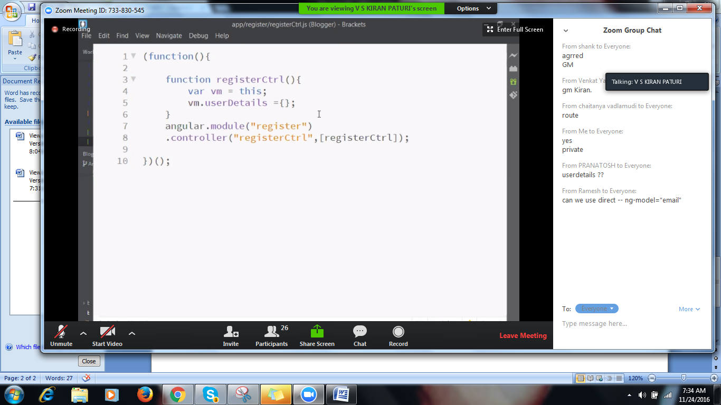

Exposing objct to view,and get captured in rc

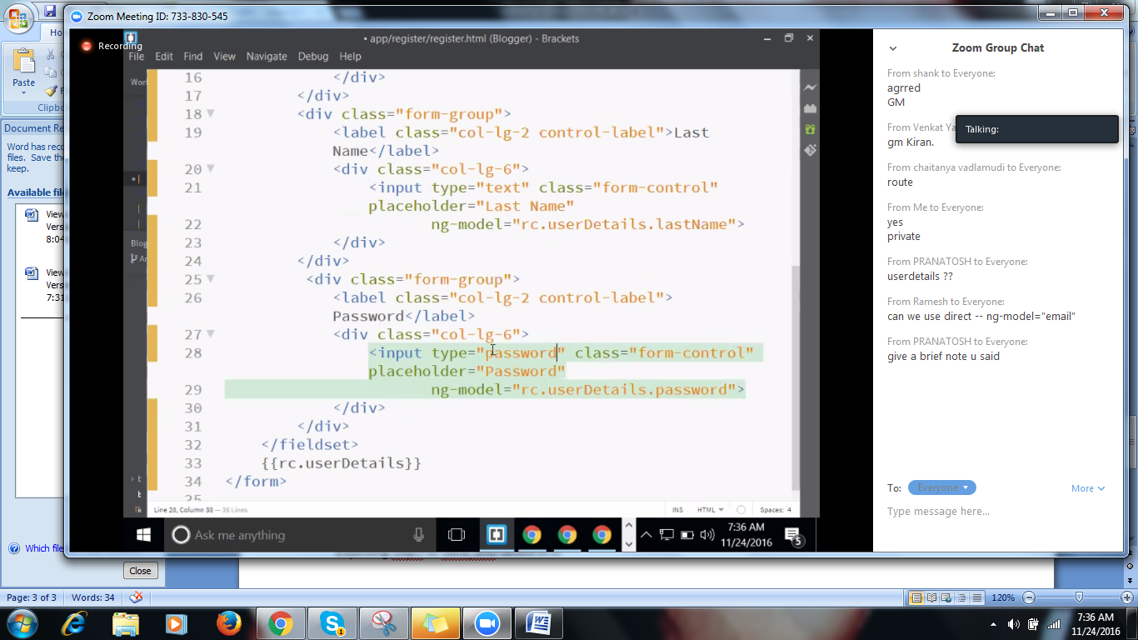

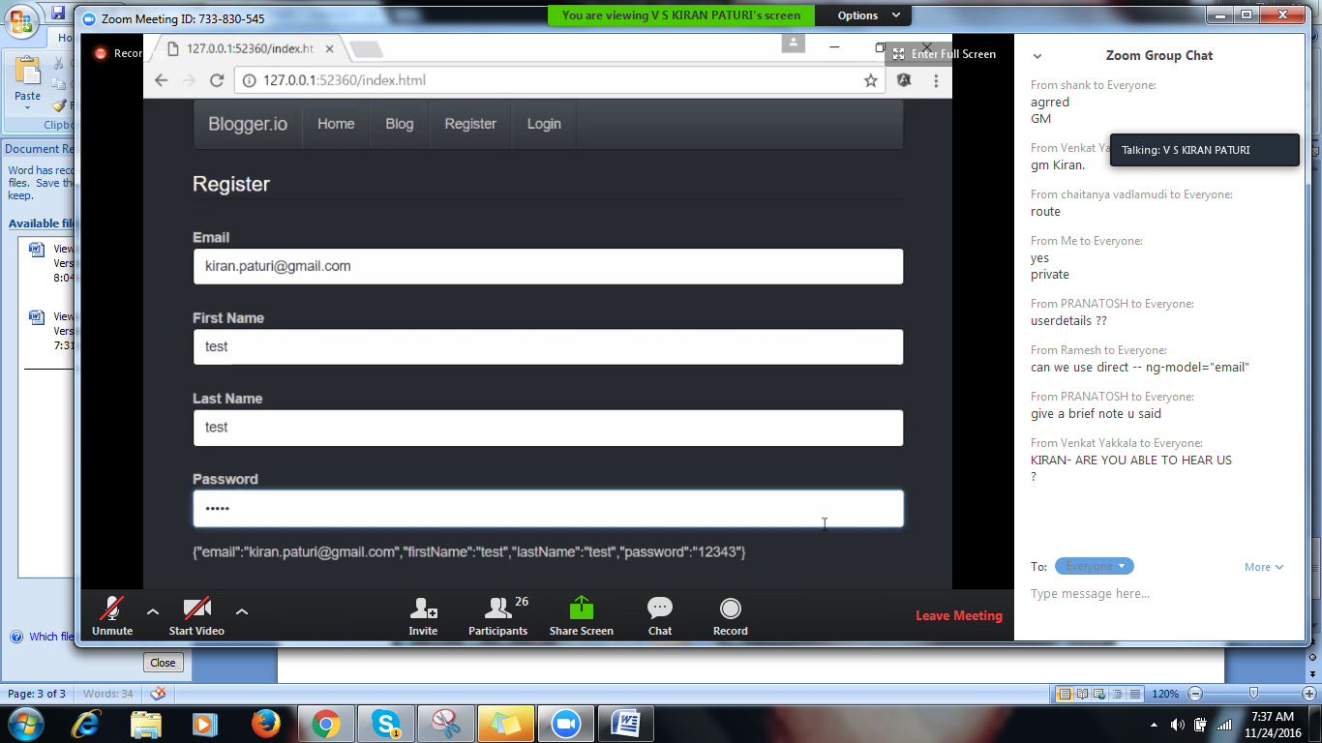

Button

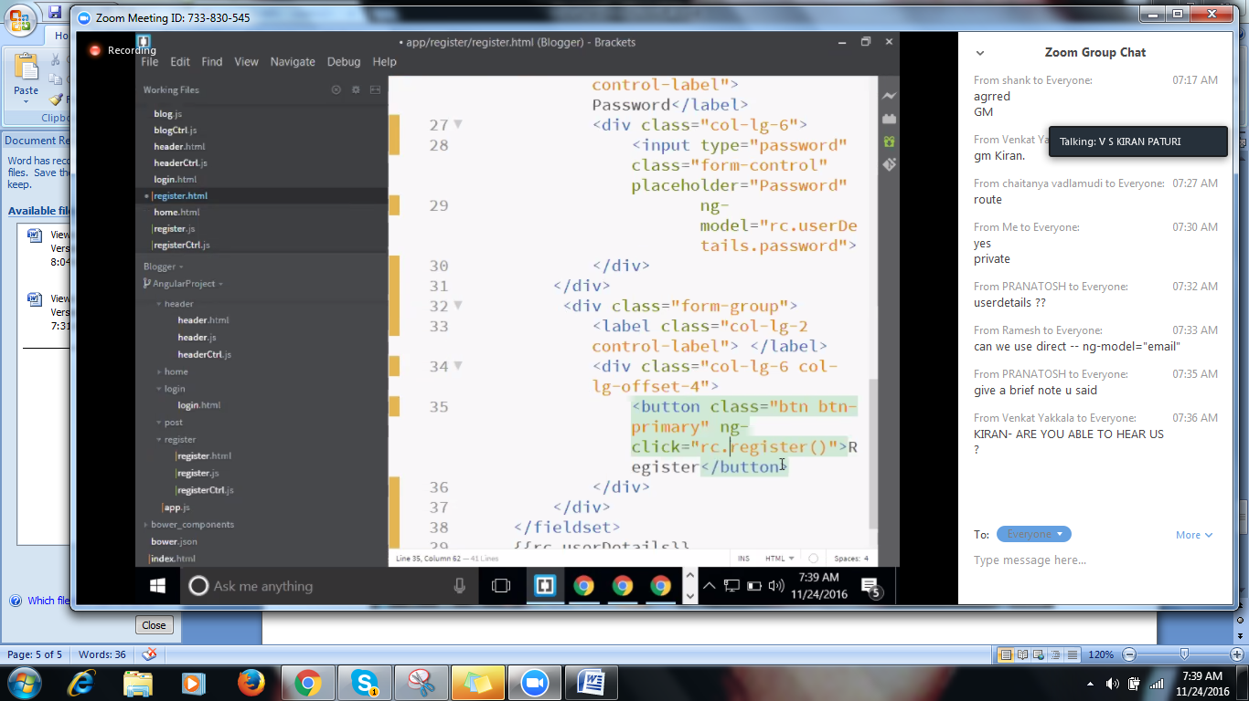

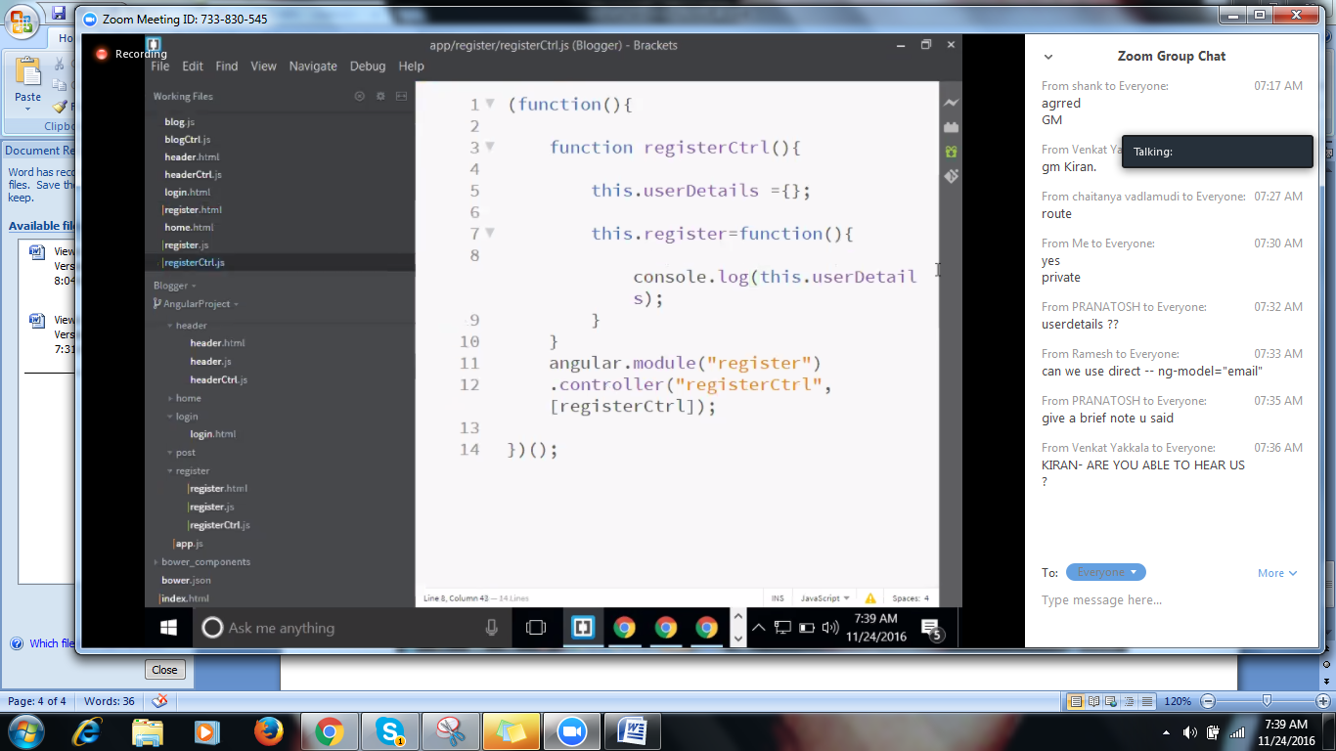

Bootswatch:HTML

To indicate the dropdown control,we will use ng-options directive,ng-options is used as ng-repeat.

Ng-options : “in collections”

To eradicate multiple option for select we are using ng-options=”country.name for country in rc.countries”

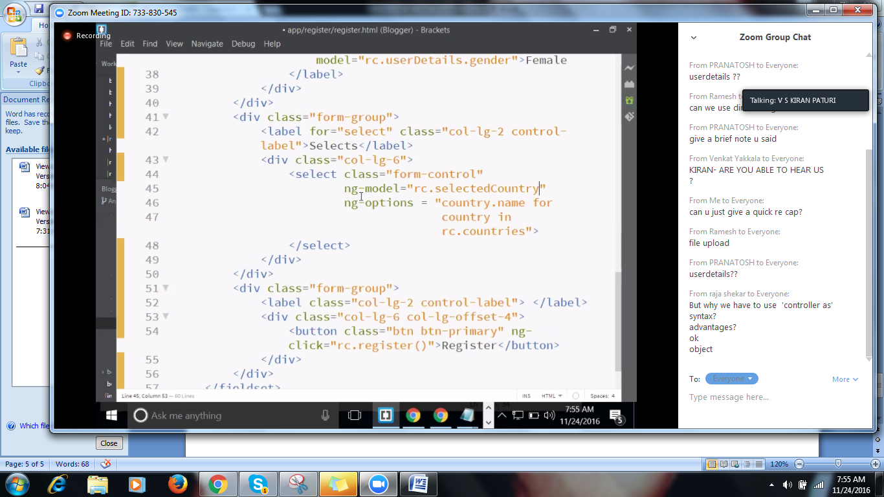

To work with ng-option,ng-model is mandatory

Rc.selectedcountry – to view the selected country on the page

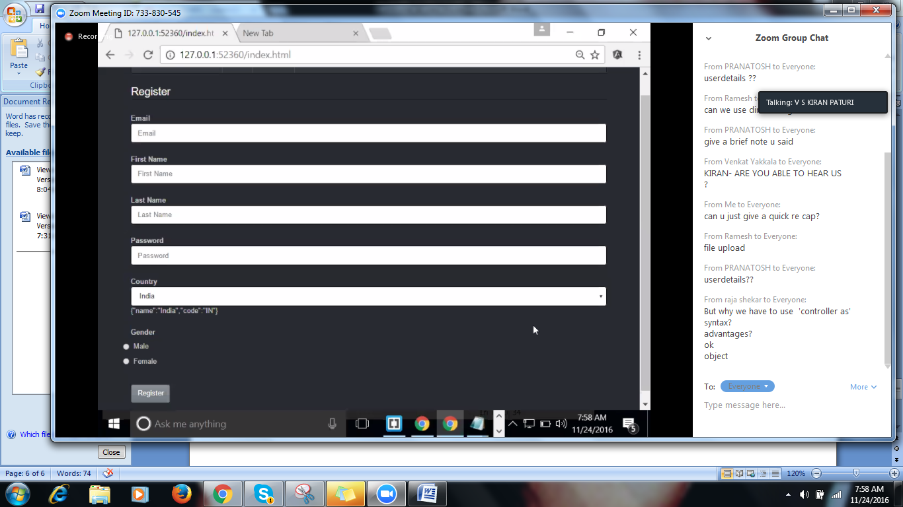

country.as name